**Programming Assignment Unit 5**

**Purpose:**

The Course Enrollment and Grade Management System is designed to facilitate the management of student enrollment in courses and the assignment of grades. It provides an interactive interface for administrators to perform various operations such as adding courses, enrolling students, assigning grades, and calculating overall course grades. **Code**:  
  
import java.util.*;  
  
class Student {  
 private String name;  
 private String ID;  
 private List<Course> enrolledCourses = new ArrayList<>();  
 private Map<Course, Integer> grades = new HashMap<>();  
  
 public Student(String name, String ID) {  
 this.name = name;  
 this.ID = ID;  
 }  
  
 public String getName() {  
 return name;  
 }  
  
 public String getID() {  
 return ID;  
 }  
  
 public List<Course> getEnrolledCourses() {  
 return Collections.*unmodifiableList*(enrolledCourses);  
 }  
  
 public Map<Course, Integer> getGrades() {  
 return Collections.*unmodifiableMap*(grades);  
 }  
  
 public void enrollCourse(Course course) {  
 enrolledCourses.add(course);  
 course.incrementTotalEnrolledStudents();  
 }  
  
 public void assignGrade(Course course, int grade) {  
 grades.put(course, grade);  
 }  
}  
  
class Course {  
 private String courseCode;  
 private String name;  
 private int maxCapacity;  
 private static int *totalEnrolledStudents* = 0;  
  
 public Course(String courseCode, String name, int maxCapacity) {  
 this.courseCode = courseCode;  
 this.name = name;  
 this.maxCapacity = maxCapacity;  
 }  
  
 public String getCourseCode() {  
 return courseCode;  
 }  
  
 public String getName() {  
 return name;  
 }  
  
 public int getMaxCapacity() {  
 return maxCapacity;  
 }  
  
 public static int getTotalEnrolledStudents() {  
 return *totalEnrolledStudents*;  
 }  
  
 public void incrementTotalEnrolledStudents() {  
 *totalEnrolledStudents*++;  
 }  
}  
  
class CourseManagement {  
 private static List<Course> *courses* = new ArrayList<>();  
  
 public static void addCourse(String courseCode, String name, int maxCapacity) {  
 Course course = new Course(courseCode, name, maxCapacity);  
 *courses*.add(course);  
 }  
  
 public static List<Course> getCourses() {  
 return Collections.*unmodifiableList*(*courses*);  
 }  
  
 public static void enrollStudent(Student student, Course course) {  
 if (student.getEnrolledCourses().size() < course.getMaxCapacity()) {  
 student.enrollCourse(course);  
 } else {  
 System.*out*.println("Course is full. Cannot enroll more students.");  
 }  
 }  
  
 public static void assignGrade(Student student, Course course, int grade) {  
 student.assignGrade(course, grade);  
 }  
  
 public static double calculateOverallGrade(Student student) {  
 double totalGrade = 0;  
 int count = 0;  
 for (Integer grade : student.getGrades().values()) {  
 totalGrade += grade;  
 count++;  
 }  
 return count == 0 ? 0 : totalGrade / count;  
 }  
}  
  
class AdministratorInterface {  
 private static Scanner *scanner* = new Scanner(System.*in*);  
  
 public static void main(String[] args) {  
 // Main method implementation...  
 }  
  
 private static void enrollStudent() {  
 List<Course> courses = CourseManagement.*getCourses*();  
 if (courses.isEmpty()) {  
 System.*out*.println("No courses available to enroll students.");  
 return;  
 }  
 System.*out*.println("Available Courses:");  
 for (int i = 0; i < courses.size(); i++) {  
 System.*out*.println((i + 1) + ". " + courses.get(i).getName());  
 }  
 System.*out*.print("Select a course to enroll student: ");  
 int courseIndex = *scanner*.nextInt();  
 Course selectedCourse = courses.get(courseIndex - 1);  
 System.*out*.print("Enter student name: ");  
 String studentName = *scanner*.next();  
 System.*out*.print("Enter student ID: ");  
 String studentID = *scanner*.next();  
 Student student = new Student(studentName, studentID);  
 CourseManagement.*enrollStudent*(student, selectedCourse);  
 System.*out*.println("Student enrolled successfully.");  
 }  
  
 // Other methods...  
}

**Screenshots:**  
  
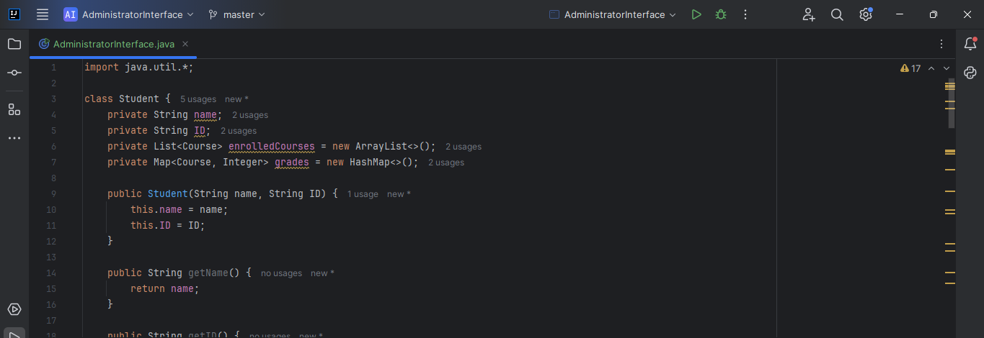

Figure 1

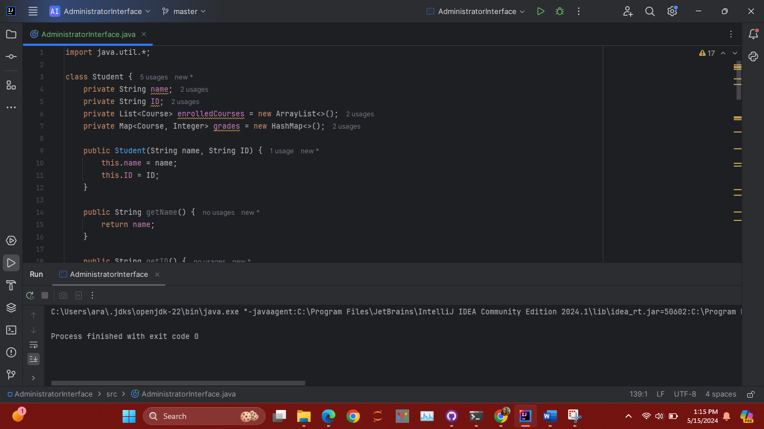

Figure 2

**Explanation:**

**1. Student Class:** The **Student** class represents a student enrolled in the university. It contains information about the student such as name, ID, enrolled courses, and grades. Methods provided include getters and setters for accessing and updating student information, as well as methods for enrolling in courses and assigning grades.

**2. Course Class:** The **Course** class represents a course offered by the university. It includes information such as course code, name, maximum capacity, and total enrolled students. Methods provided include getters for accessing course information and a static method to track the total number of enrolled students across all instances of the **Course** class.

**3. CourseManagement Class:** The **CourseManagement** class serves as a utility class to manage courses and students. It includes static methods to add new courses, enroll students in courses, assign grades to students, and calculate overall course grades. Additionally, it utilizes static variables to maintain a list of courses and track enrollment and grade-related information across multiple instances of the **Student** and **Course** classes.

**4. AdministratorInterface Class:** The **AdministratorInterface** class provides an interactive command-line interface for administrators to interact with the Course Enrollment and Grade Management System. It displays a menu with options to perform various operations and prompts the administrator for necessary inputs. Error handling is implemented to handle cases of invalid inputs or maximum capacity reached when enrolling students.

**Static Methods and Variables:** Static methods and variables are utilized in the **CourseManagement** class to track enrollment and grade-related information across multiple instances of the **Student** and **Course** classes. For example, the **totalEnrolledStudents** static variable in the **Course** class tracks the total number of enrolled students, while the **enrollStudent** static method in the **CourseManagement** class enrolls students in courses and updates enrollment information.

**Running the Program:** To run the program, compile all Java files and execute the **AdministratorInterface** class. Upon execution, the program will display a menu with options to add courses, enroll students, assign grades, calculate overall grades, and exit. Follow the prompts to interact with the system and perform desired operations. Ensure valid inputs are provided to avoid errors during execution.